Nonsuch Primary School

This policy is embedded in our school's mission statement of, 'Working Together We All Achieve'.



Policy | Uniform Policy
Date | September 2026
Date for review | September 2029

We serve our community by providing an education of the highest quality. We believe our school should be a place where we all want to be, a place where children and adults feel safe, happy, secure and nurtured.

Our Vision at Nonsuch Primary School
We serve our community by providing an education of the highest quality. We believe our school should be a place where we all want to be, a place where children and adults feel safe, happy, secure and nurtured.
Our high expectations for learning cultivates character and pride in our identity at Nonsuch Primary School preparing every child for their future.

1. Aims
• Set out our approach to requiring a uniform that is of reasonable cost and offers the best value for money for parents and carers.
• Explain how we will avoid discrimination in line with our legal duties under the Equality Act 2010.
• Clarify our expectations for school uniform.

2. Our school’s legal duties under the Equality Act 2010
The Equality Act 2010 prohibits discrimination against an individual based on the protected characteristics, which include sex, race, religion or belief, and gender reassignment.
To avoid discrimination, our school will:
• Avoid listing uniform items based on sex.
• Make sure that our uniform costs the same for all pupils.
• Allow all pupils to have long hair.
• Allow pupils to request changes to swimwear for religious reasons.
• Allow pupils to wear headscarves and other religious or cultural symbols.

3. Limiting the cost of school uniform
Our school has a duty to make sure that the uniform we require is affordable, in line with statutory guidance from the Department for Education on the cost of school uniform.
We will make sure our uniform:
• Is available at a reasonable cost.
• Provides the best value for money for parents/carers.

4. Expectations for school uniform
Please note that our uniform is not gender specific and pupils have the freedom to choose the items of uniform they are comfortable with.

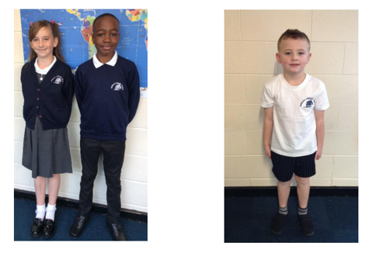
Uniform:
• Blue sweatshirt/cardigan with or without logo
• White / pale blue polo shirt
• Black or grey trousers/skirt/dress
• Summer dress (blue/white)
• Black shoes – NOT TRAINERS
PE Kit:
• White shirt
• Black / blue shorts
• Black pumps (indoors), trainers (outdoors)
• Tracksuit/sweatshirt for outdoors
• Plain swimming costume or swimming trunks
Jewellery:
• Small stud earrings only
• Watches may be worn
• Religious jewellery may be worn
Hairstyles:
At Nonsuch Primary School, we believe that hairstyle is a personal choice and therefore school does not require or place limitations on hairstyles. However, there may be times when pupils have long hair, they are required to have it tied back in some form.

5. Where to buy uniform
Parents and carers are welcome to purchase suitable plain uniform items, in the correct school colours, from supermarkets or other high-street retailers in line with Department for Education guidance to ensure uniform remains affordable. There is no expectation for items to be branded with the school logo.
Branded items, if preferred, can be purchased from:
Somal Fashions
11 Faraday Avenue,
Quinton,
B32 1JJ
0121 423 2969

6. Expectations for our school community
Pupils are expected to wear the correct uniform at all times while on the school premises, travelling to and from school and representing the school.
Parents/carers are expected to ensure uniform is clean, labelled and in good condition.
Staff will monitor uniform expectations and support families where required.

7. Monitoring arrangements
This policy will be reviewed annually by the Headteacher/Local Academy Board.

