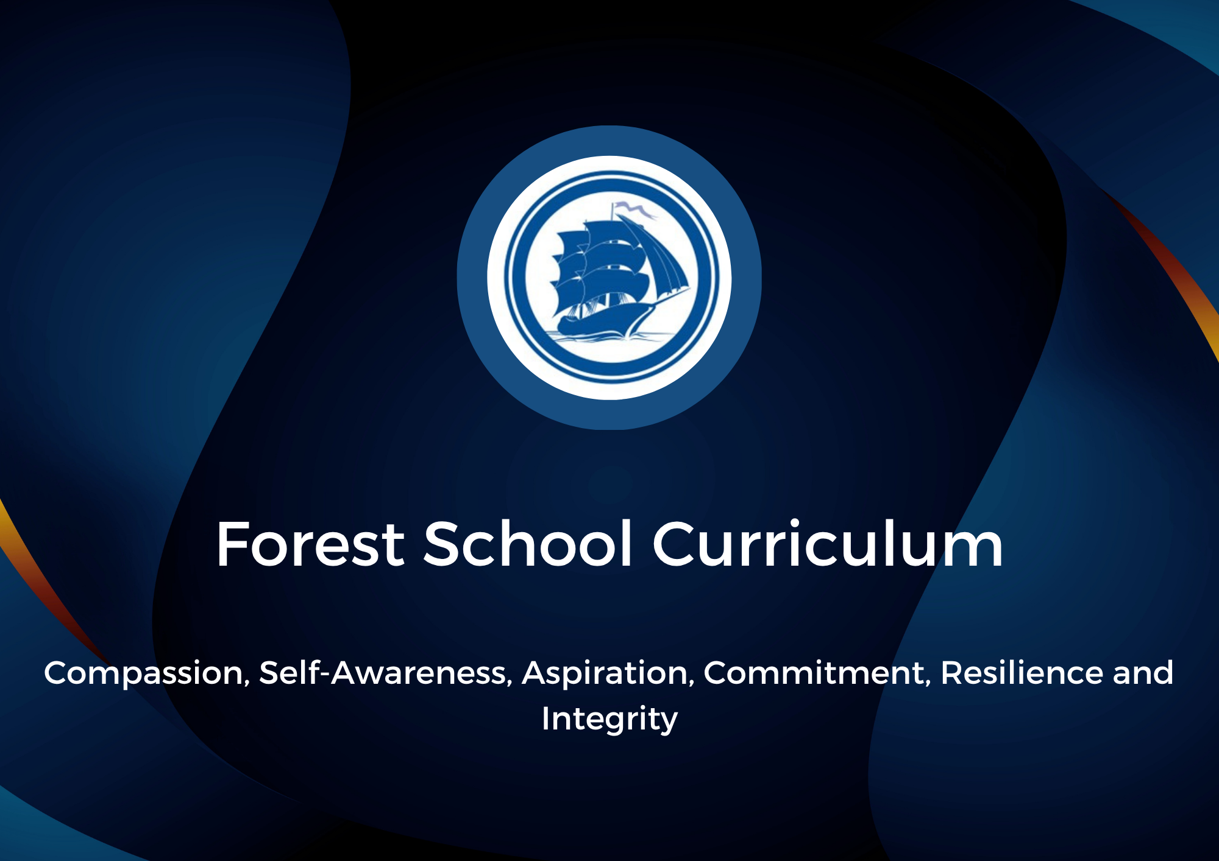

Holistic development through Forest School – Acronym -PILES
Social, Language and Emotional wellbeing

- Forest School allows them to connect with other people in the community and play or work with others that they may know less well.

- It can challenge their emotions whereby they have to show continued resilience in the face of frustration but through communication and social environment they can be helped and supported by peers for example, how to make a stick that keeps falling stay up for building a den.

Social, Language and Emotional wellbeing

- Mental and emotional wellbeing is supported through connecting holistically with nature as it has a calming and peaceful effect on the body and reduces signs of stress or anxiety. This is backed by the NHS get wild - https://www.england.nhs.uk/get-wild-for-the-nhs/ as they have evidence that being in nature has a overall health boost and aids recovery in patients.

- When the facilitator encourages activities such as den or shelter building. Learners can be observed sharing ideas, using increasing levels of vocabulary as they communicate their ideas, thoughts and struggles during the they are going to use, how they are going to place it or adapt it.

Social, Language and Emotional wellbeing

- FS has a high focus on the importance of play with supports the development of social skills and language through play – interaction and co-operation

- Where the facilitator provides a range of choice in activities for the learners, different types of development can occur as play is less inhibited or controlled by adults. This allows for play to drive learning. This is backed by the Psycholudics theorists Gordon Sturrock and Perry 1988.

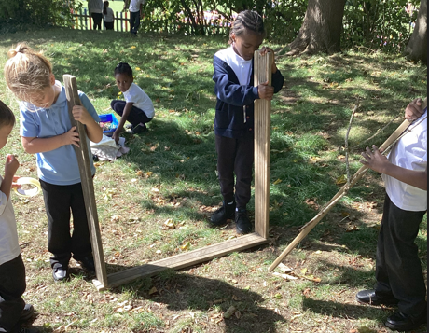
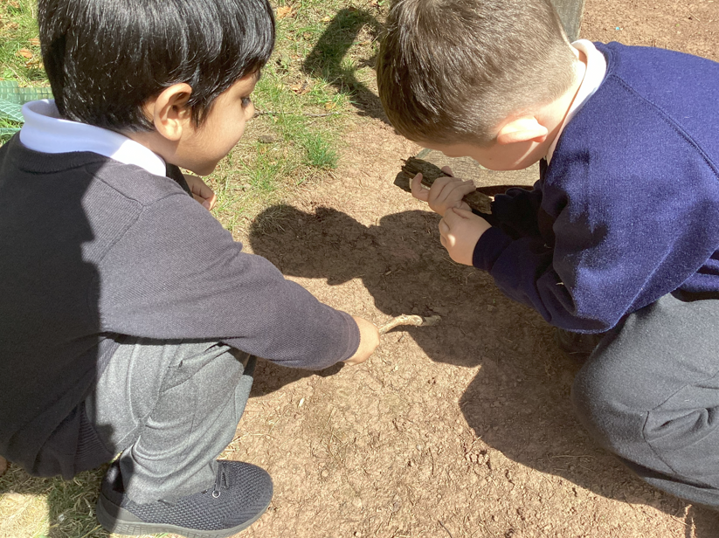

Intellectual development and wellbeing

- In FS learners can experience mistakes and see them as positive experiences or steps in their learning which might be more negative within a classroom environment.

- It provides learners with life long skills such as the ability to display greater problem solving skills through being encouraged to have a flexible growth mindset to open up new talents and abilities rather than a fixed mindset which can limit this. Although the development may look different from one learner to another it does not mean that one is more intelligent than the other.
.

Intellectual development and wellbeing

- In FS it is important for the facilitator to take time to step back and observe and our the learner to develop independence in their learning and to experience struggle.

- However, they need to be ready to step in when the learners well being or interest will be affected by the struggle and will need to adapt their involvement to provide clear support to reduce that struggle and allow the learner to feel successful in the task.

- FS allows learners to learn new skills such as knot tying, building structures and use of tools or fire through play or a environment they feel safe in.
Intellectual development and wellbeing

- In FS it is important for the facilitator to take time to step back and observe and our the learner to develop independence in their learning and to experience struggle.

- However, they need to be ready to step in when the learners well being or interest will be affected by the struggle and will need to adapt their involvement to provide clear support to reduce that struggle and allow the learner to feel successful in the task. This is backed by the theory of Zones of proximal development by the theorist Lev Vygotsky 1920.

Physical development and wellbeing

- The more a learner is praised for their attempts the more self confident they become and willing to experiment.

- The hands on, practical use of moving and transporting loose parts to build awareness of own limits or challenging their own physical ability is backed by theorist Simon Nicholson 1970 that loose parts create play that is imaginative and provides opportunities for self discovery where natural or man made.

Physical development and wellbeing

- FS encourages and provides opportunities for learners to be physically active through warm up games, activities and reflection activities

- It develops fine motor skills (knot tying and tools) and gross motor skills (through throwing, using large sticks to paint with mud etc) through play based learning.

- The use of loose parts allows the learner to change the fixed purpose of an item and allows them to explore with an open mind how else it can be used.

Intellectual development and wellbeing

.
- Open ended tasks which are not closely dictated in how they need to look or be can lead to learners displaying high or very high levels of involvement. As learner shows increased or high levels of concentration, creativity and energy and not easily distracted during their continuous activity throughout an observed period of time which is supported by the Leuven scale of wellbeing and involvement.

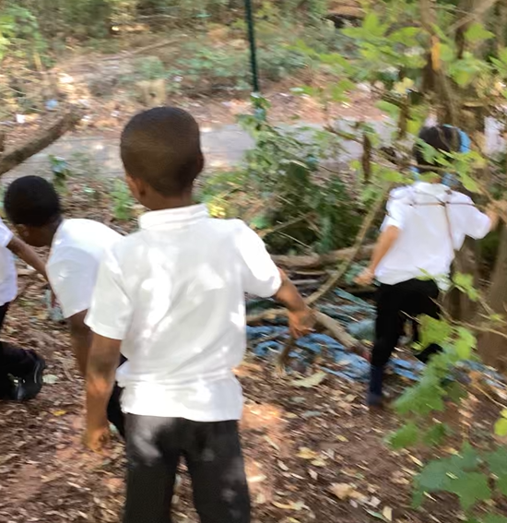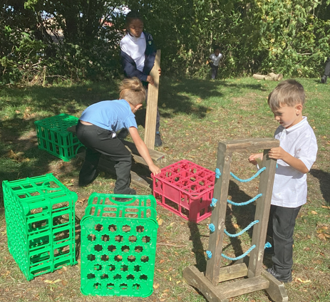

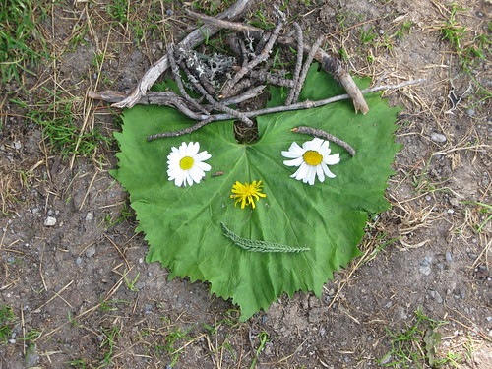
Holistic Learning and development

Forest school promotes holistic development through its emphasis on the importance of play and enjoyment which supports the following outcomes; interpersonal skills, social, emotional, mental, physical and intellectual elements (language and communication). Experiencing all these develops deeper learning.
Allowing for reflection allows them to pay attention to the present moment and reflect on successes so they become a more rounded, confident person that can show resilience when faced with challenges.

This Photo by Unknown Author is licensed under CC BY-SA
Physical development and wellbeing

- Physical development supports well being as active physical engagement allows learners to display high or very high levels of well being where there are obvious signs of satisfaction, they are happy, cheerful and full of energy which helps build a learners self confidence and self assurance with no signs of stress or tension (Lev Vygotsky 1920)

