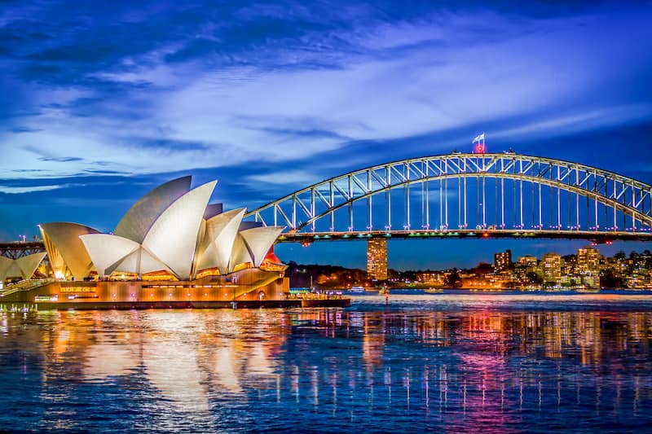

**English:** In English this half term, we will be using the key text drivers ‘The Koala Who Could’ and ‘Mirror’. From these texts, Year 2 will be writing a narrative and a letter which in which they will be identifying and applying, conjunctions, apostrophes for possession, dialogue, commas in a list and expanded noun phrases.

**DT:** This half term, Year 2 will be looking at Bill Granger and his life as a chef. From this, Year 2 will look at the foods we need to eat to have a balanced diet. Year 2 will then look at the ingredients needed to create a variety of healthy salads.

**Science:** In science this half term, Year 2 will be investigating seeds, bulbs and plants and recognising the conditions required for germination and healthy plant growth.

**Diversity Texts:** Our diversity texts are: The Name Jar by Yangsook Choi, Gregory Cool by Caroline Binch, Coming to England by Floella Benjamin, Sulwe by [Lupita Nyong'o](https://www.amazon.co.uk/s/ref=dp_byline_sr_book_1?ie=UTF8&field-author=Lupita+Nyong%27o&text=Lupita+Nyong%27o&sort=relevancerank&search-alias=books-uk), Martin Luther King Jr. (Little People, BIG DREAMS) J is for Jamaica by Benjamin Zephaniah and Ramadan Moon by Na’ima B Robert.

**Mathematics:** Year 2 will be focussing on addition and subtraction, money and faces, shapes and patterns; lines and turns this half term. In their MOT lessons, year 2 will be looking at addition, subtraction, multiplication and division to embed this knowledge and further their quick recall of number facts.

**Summer 1 - 2025 – Class 2B are learning about:**

**Why is our world wonderful?**

In geography this half term, Year 2 will be exploring why our world is so wonderful. Year 2 will first look at geographical characteristics of the UK and then locate some of the world’s most amazing places, looking at both the human and physical characteristics. Year 2 will explore the five oceans and locate them on a map. Looking at our local area, Year 2 will draw human and physical features on a map, investigate the local habitats and look at how we can look after our natural habitats.

**PE:** Year 2 will be looking at 2 units this half term: Send and Return and Dance. They will be looking at their throwing and catching techniques as well as their ability to create a sequence of moves individually and as a group.

**Music:** Year 2 will be developing an understanding of structure by exploring and ordering rhythms.

**RE:** In RE this half term, Year 2 will be focussing on Islam and will be discussing the key features of a mosque and their significance o the Islamic faith.