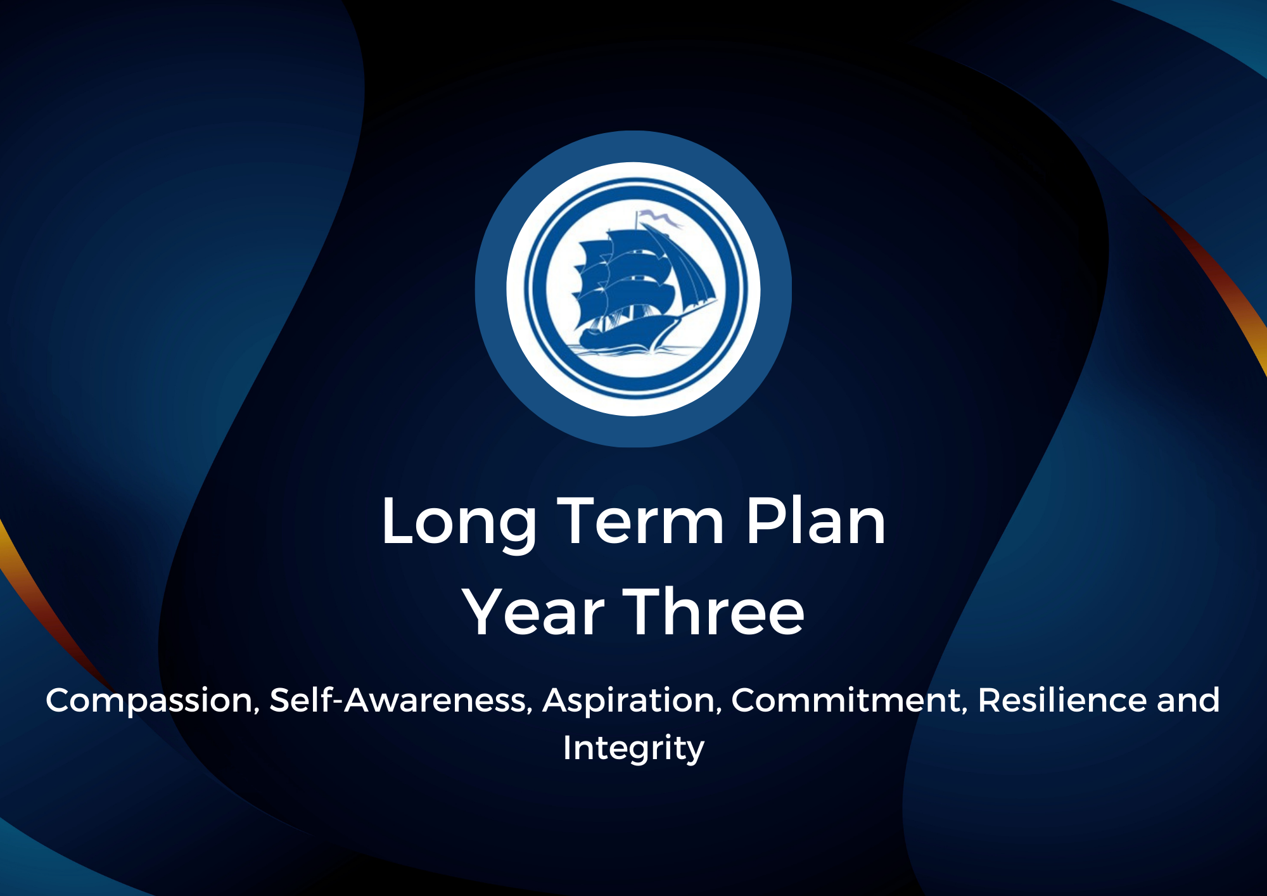

2024/2025 Curriculum Map
Year Group: 3
Working Together We All Achieve

YEAR 3 | Autumn |  | Spring |  | Summer
Term | Autumn 1 | Autumn 2 | Spring 1 | Spring 2 | Summer 1 | Summer 2
Nonsuch  Learning  Behaviours | Ready  Respectful  Responsible | Ready  Respectful  Responsible | Ready  Respectful  Responsible | Ready  Respectful  Responsible | Ready  Respectful  Responsible | Ready  Respectful  Responsible
Nonsuch Life  Skills | Compassion  Self-Awareness  Aspiration  Commitment  Resilience  Integrity | Compassion  Self-Awareness  Aspiration  Commitment  Resilience  Integrity | Compassion  Self-Awareness  Aspiration  Commitment  Resilience  Integrity | Compassion  Self-Awareness  Aspiration  Commitment  Resilience  Integrity | Compassion  Self-Awareness  Aspiration  Commitment  Resilience  Integrity | Compassion  Self-Awareness  Aspiration  Commitment  Resilience  Integrity
British Values | Rule of Law | Rule of Law | Democracy | Individual Liberty | Mutual Respect | Tolerance
Educational Visits/Visitors | The History Man  Blackwell Outdoor Trip | Trip to Woodgate Valley  Country Park | Buddhist Temple | History Man | Library Visit | British Transport  Museum
Oracy Opportunities | The History Man | Letter from Bear Grylls | Food Tasting | The History Man | Hunting for Artefacts | British Transport  Museum
Oracy Opportunities | Present Stone Age  Poem to parents/carers | Building Survival Shelters |  | Egyptian School Display | Re-enactment of the defeat of Boudicca | Create and follow own maps of the local area.
History | Stone Age to Iron  Age |  |  | Egyptians | Roman Britain
Geography |  | Who lives in Antarctica? | Why do people live near volcanoes? |  |  | Are all settlements the same?

Science | Biology: Animals: Movement and nutrition | Physics:  Forces and space: Forces and Magnets | Physics: Rocks and Soils | Energy: Light and shadows |  | Plants: Plant reproduction | Making connections: Does hand span affect grip strength?
Scientist | Christiaan  Huygens | Albert Einstein | Antoine Lavoisier  Marie Curie | Inge Lehmann |  |  | Katherine Esau
Writing Purposes | Poetry  Fiction  Non-Fiction | Fiction Non-Fiction | Poetry  Fiction  Non-Fiction | Fiction Non-Fiction | Poetry  Fiction  Non-Fiction |  | Fiction Non-Fiction
Computing | Computer systems and networks 1  Networks and the internet | Programming | Computer systems and networks 2  Emailing | Computer system and networks 3 | Creating media |  | Data handling
Maths | Maths on Track – computation skills  Number Sense and Exploring Calculation Strategies  Place Value  Graphs | Maths on Track – computation skills  Addition and  Subtraction  Length and perimeter | Maths on Track – computation skills  Multiplication and  Division  Calculating with Multiplication and  Division | Maths on Track – computation  skills  Time  Fractions | Maths on Track – computation skills  Angles and Shapes  Mass and Capacity |  | Maths on Track – computation skills  Applying multiplicative thinking  Exploring calculation strategies and place value
Art |  | Prehistoric Art |  |  | Formal Elements of Art |  | Craft with element of Art and Design Skills
Artist |  | Caroline Ross |  |  | Christoph Niemann |  | Ann Roth

Design Technology | Textiles: Cushions |  | Structures: Constructing a Castles | Spring 2 Digital World: Electronic Charm Unit
Designer | William Morris – British Textiles Designer |  | Antoni Gaudi - Spanish Architect | Louis Vuitton – French Fashion Designe
R.E. | Sikhism: Khalsa | Christianity: Christmas | Buddhism:  Buddhist Temple |  | Christianity: Easter | Hinduism: Brahman | Sikhism: Sharing
Music | Ballads | Creating compositions in response to animations (Theme: Mountains) | Developing singing technique. (Theme: the Vikings) |  | Pentatonic melodies and composition. (Theme: Chinese New Year) | Jazz | Traditional instruments and improvisation (Theme: India)
MFL | Getting To Know  You | Phonics | Introductions |  | Letter and sound connections | Verbs and adverbs | Creating sentences
P.S.H.E. | Being in My  World | Celebrating Difference | Dreams and Goals |  | Healthy Me | Relationships | Changing Me
P.E. | Football  OAA | Handball  Dance | Netball  Gymnastics |  | Badminton  Tag Rugby | Cricket  Rounders | Tennis  Athletics
Parental Involvement | Parent’s Evening  Reading Workshop | Coffee Morning  Anti-bullying workshop | Parent’s Evening  Art/DT Workshop |  | Coffee  Morning  World Book Day Workshop | Parent Lunch | Sport’s Day  Computer Workshop  Parent’s Evening
Charity/  Fundraising |  | Children in Need  Christmas Jumper Day |  |  | Comic  Relief/Sports Relief |  | Class Charity Fundraising Event
Performance | Assembly on Sikhism |  |  |  | Easter Assembly | Music Assembly

