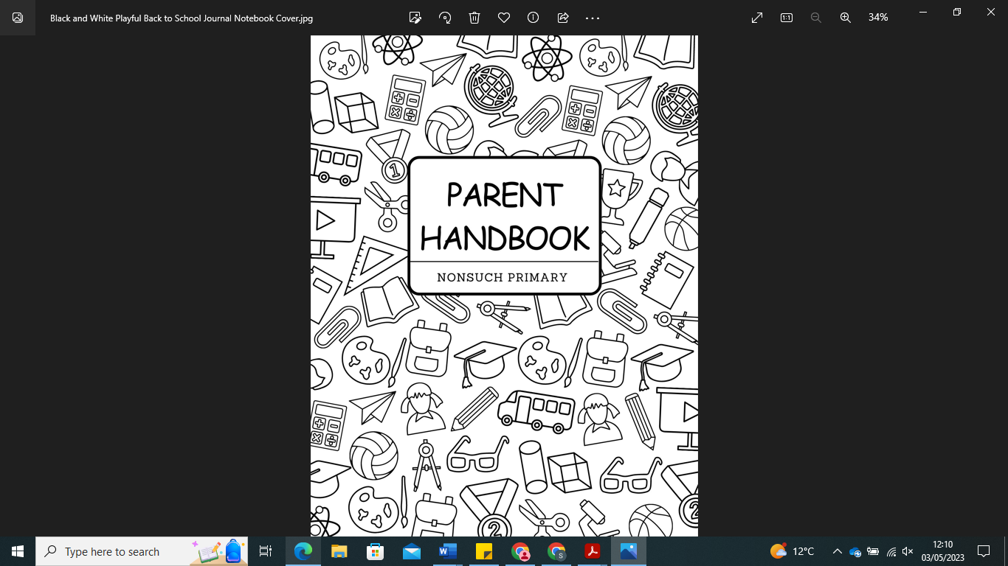

Our Vision
Our vision is encapsulated in the words:
'Working Together We All Achieve.'
We believe that through the whole community working together, we can inspire the children to become lifelong independent leaders who are proud of their community and identity at Nonsuch Primary School. Our vision is underpinned by the three key learning behaviours of Ready, Respectful and Responsible.

Welcome to Nonsuch Primary School
'Working Together We All Achieve.'
How to contact us:
Nonsuch Primary School
Wood Leasow
Woodgate Valley
Birmngham
B32 3SE
Telephone: 0121 464 2064
Email: Office@nonsuch.bdmat.org.uk
Website: www.nonsuch.bham.sch.uk

Acting Executive Headteacher: Mr Watkins
Acting Head of School: Mrs Sanders
Business Manager: Miss Wenlock
School Administrator: Mrs Hook

Our School Timetable:
Reception: 8:40am start 3:20pm finish
KS1 and KS2 8:40am start 3:20pm finish

Attendance:
To gain the most benefit from their education, children need to attend school regularly and daily. Attendance is statutory. The school target is at least 96%attendance for each child.

Under 5's
Nonsuch's Policy is that all children, regardless of age, attend school daily unless ill. This applies to all children, including those in Reception. Routine is essential for children to flourish, and getting them to understand the importance of school as early as possible sets them up for the rest of their academic careers. For this reason, when accepting a place at Nonsuch Primary School, you agree to your child attending punctually every day.

Holidays
As you will be aware, schools can no longer authorise leave of absence (holidays) during term time unless there are exceptional circumstances. These do not include attending weddings or visiting relatives abroad. If you do need to take a leave of absence, the local authority has issued schools with forms that need to be completed. Please understand that the local authority decides if penalty notices are issued.

Punctuality
It is vital for your child's education that they attend school regularly and on time. Failure to do this can affect their academic and social progress. Children can also feel left out and isolated from their friends.

If children are late, they disrupt and miss instructions which could affect them during the rest of the lesson. Please note that the school date starts promptly at 8:55 am and that even arriving 5 minutes late daily means your child will have missed 25 minutes of learning each week. Over a term, this can result in nearly a full day. Children who are persistently late will be referred to the same agencies as persistent absentees.

First Day Calls
Where a child is absent from school, and no reason has been given, the school will contact the parent or carer to determine the reason for absence. If you know that your child is ill or that they will be absent from school, please inform the school office so that we do not have to disturb you.

School Uniform
The school uniform policy applies to all pupils. These clothing items have been chosen because they are comfortable, safe and appropriate for the activities undertaken at school. We are keen to build on the outdoor learning that takes place within the school. This means there may be times when we ask you to provide wellies and a waterproof/windproof jacket so that the children get outdoors as much as possible.
Our uniform consists of the following:
Blue sweatshirt/cardigan with school logo
White top – polo skirt or white blouse
Black or grey trousers/skirt/pinafore dress/shorts (blue gingham in summer)
Flat black shoes (no trainers)
Black or grey socks
PE Kit:
On PE days, children are to arrive to school already in their PE kits. Children should wear their school jumper over their PE kit.
PE Kit List:
White t-shirt/polo
Black or blue shorts
Black or blue jogging bottoms
Black pumps or trainers
Swimming costume or swimming trunks (not shorts or bikinis) when needed

Jewellery
For safety reasons, children do not wear jewellery at school; watches and stud earrings are the only jewellery allowed – these need to be removed for PE.
PE is a vital part of the curriculum, and your child will be asked to wear PE kits on PE days. If they are not wearing it, we will phone home and ask for it to be dropped off at school.
Please ensure your child's clothing is labelled with their name so they don't get lost or mixed up in their class.
We ask all parents who send their children to our school to support the school uniform policy. If you wout like to see a copy, please contact the School Office or look on the school website.

Breakfast and After School Clubs
There is the option for your child to attend breakfast club. This starts at 8:00 am daily and finishes at 8:45 am. This is at a charge of £5.00 per child, and they will receive breakfast.
There is also the option for homework club. This runs Monday to Wednesday from 3:15 pm until 4:15 pm. This comes at a charge of £2.50.

After-school sports clubs for Reception start in the Summer term. Please speak to the School Office if you would like more details.

Our Curriculum
We deliver a broad and balanced progressive curriculum based on the school's aims and reflecting the close links with the local area. The curriculum has been designed to meet the needs of the children at Nonsuch Primary School. It supports the children in learning fun and meaningfully – ensuring that they are motivated, stimulated and keen to learn.

We are fortunate to have teaching assistants to support the children at Nonsuch should your child need additional support to reach their full potential.

The Inclusion Lead assesses children with Special Educational Needs, and the correct supporting provisions will be implemented.

Some children are given 1-1 support and group tutoring to ensure they achieve their full potential. Pupil Progress meetings occur half-termly so that any child at risk of underachieving is quickly identified and strategies put in place. We use Pupil Premium funding to provide extra support for those entitled to support them. We also use Pupil Premium to buy in extracurricular activities such as music.

Charging and Remissions Policy
Parents will be invited to make a voluntary contribution towards some activities. In such cases, it will be pointed out that these activities will only go ahead if sufficient voluntary contributions are forthcoming. Children will never be excluded from the activity because their parents cannot contribute. An additional contribution to cover the cost for these children will not be imposed on those parents who are able and willing to contribute.

Education Outside School Hours
Parents may be charged for activities that happen outside school hours when these activities are not a necessary part of the National Curriculum or religious education or an essential part of the syllabus for an approved examination. Such activities will be regarded as 'optional extras'.

Medical and Social Care
Parents MUST inform the school of any medical concerns, particularly allergies, asthma and epilepsy, or if your child is attending hospital for any reason.

No staff can give medicines of any kind to the children without a medical prescription. School Medical Forms will be required to be completed by the parent before we can administer it. Children with asthma must keep an inhaler in school at all times and it must be in its box with a prescriptive sticker.

With the exception of inhalers and epi-pens, no medicine is kept in classrooms. However, health details are kept in classrooms to ensure all staff, including supply staff, are aware of any issues.

Staff will supervise and provide help if required for children using an inhaler. It is the parent/carer's responsibility to ensure that inhalers are up to date. However, we will endeavour to advise parents when inhalers need replacing.

The class teacher or first aider will inform you if your child has an injury or illness, which you should be aware of.

On admission, you will be asked to provide at least two emergency contact telephone numbers. If, for any reason, either of these numbers changes or your own mobile number changes, please inform the school immediately.

Parents are advised to keep children at home for 48 hours after a bout of sickness and/or diarrhoea. During infectious illnesses such as chicken pox, children must be kept at home and parents should follow medical advice on when their child can return to school.

Headlice
From time to time, children come in contact with headlice. Please inform the school if this happens so that we can inform other parents in your child's class to be extra vigilant. If your child has live lice, we will ask you to administer treatment before returning your child to school. Please note, however, that children should not be kept off school because of headlice. They should be treated and then brought into school.

Wetting and Soiling
There are occasions when a child may wet or soil themselves at school. However, whilst there is no compulsion on the school to deal with a problem of this nature, the school will never leave a child in this condition if at all possible.,
If this occurs, we will provide clean clothes for them to change into; however, if your child is unable to change him/herself for any reason, we may need to contact you to assist with changing your child.
Please ensure the office has your up-to-date contact details - it is very upsetting for your child to be in soiled clothes and wet; we would never leave a child willingly in this condition. Our Policy is to only change them as a last resort with two volunteer staff members. If the problem is consistent, a meeting may be required between the inclusion lead and the parent/carer.

Collective Worship
This is a whole school worship, key stage and class worship content. We will regularly invite parents to join us during these sessions.

Behaviour
We work on the principle that children's behaviour is central to their learning and education and that mutual respect is essential. Therefore, it is important that the whole school environment is organised to encourage this type of response and that positive approaches to behaviour are carried out wherever possible. We also believe in involving parents at the earliest opportunity if there are any behaviour problems and working alongside the parents to try to solve these problems. Please refer to our anti-bullying and behaviour policies available at the school office or on our website.
To further involve children, we have a school council where two children, who have been elected from each class, meet regularly to discuss any concerns and ways of improving school life for everyone.

Special Educational Needs
Our school is an inclusive school with a broad and balanced curriculum which is differentiated to accommodate the needs and abilities of individual children Systems are in place for the early identification of barriers to learning and participation. All staff members have high expectations of all children and set suitable targets for them.

Concerns and Complaints
Any parent wishing to make a complaint about any aspect of school life should talk to their child's class teacher in the first instance, then the Assistant Head or Head of School. Should a formal complaint be made, the school will follow the Complaints Procedure. Should copies be required, they are available from the school office or on the school website.

Parent Support
We encourage parents to join in school life, and if you would like to help in any way b hearing readers or working with a group of children using computers, art or technology, please see the Head of School or contact the school office. We also hope parents will support the school by following the school's homework policy.
Please note that Nonsuch will not tolerate aggressive behaviour, whether verbal or physical, towards children or members of staff. Should this occur, they will be informed, and the offenders may be banned from the site.

School Dinners
Our school offers a choice of hot meals which have the recommended nutritional content. Children in Reception are now entitled to Universal Free Meals provided by the school. You can still provide your child with a packed lunch if you would prefer, but we suggest you encourage your child to try a school lunch to provide them with a varied and balanced diet. A sandwich option is provided each day. If you receive income support, job seekers allowance or child tax credits, then the school is entitled to Pupil Premium funding. This allows Nonsuch to receive a significant amount of additional funding which is used to enhance your child's learning.

Children who prefer to bring packed lunches need to bring a named plastic lunch box with a healthy and nutritious lunch inside. We have a Healthy Eating Policy at Nonsuch, which we ask you to support. Definitely no fizzy drinks or sweets, please!

Toast
Your child will receive milk free of charge until they are five years old. Your child will also receive free fruit during break time. There is an extra charge for toast. Children may order toast for break time. This needs to be ordered via School United. This comes at a charge of 25p per day.

Smoking
We have a complete no-smoking policy (including vaping) for all staff and parents while on the school site.

Alcohol
No practitioner will be under the influence of alcohol or any other substance which may affect their ability to care for children at any time. Children will not be released to adults who appear to be intoxicated.

Dogs
Dogs are not permitted on the school site. If you are by the school's gates with dogs, these need to be tied up and on a lead.

Safeguarding
All personnel who work in direct contact with children have enhanced Criminal Records Check, now known as a Disclosure and Barring Service (DBS). Any parent volunteers helping within the setting are also subject to a DBS. Students who work within the school are required to be DBS checked. All these records are kept within the school.

Travelling to and from school
We actively encourage safe walking, safe cycling and safe use of public transport to reduce the number of cars on the road. This not only ensures that children are active and fit but is also a way to help the environment. Children are very welcome o cycle or scooter to school, and we have pods for children to store their bikes during the day. They will need to provide their own locks, and parents are responsible for ensuring their child has the correct safety equipment. Please note that bikes and scooters are left at their own risk.

Security
Staff will only release children into the custody of adults named on the admission form. If, for any reason, a child is being collected by a different person, the school office MUST be made aware of this as soon as possible. Failure to do so will mean that staff will not release the child. Under no circumstances will a child be allowed to leave the premises without supervision.
All school visitors must sign in and out at the main Reception. A visitor badge will be given, which should be worn at all times to identify. All doors are fob protected to prevent entrance by anyone other than members of staff. All play equipment is regularly inspected for damage.

Educational visits
During educational visits, our prime concern is the safety of the children. To ensure this, the following takes place:
- Risk assessments are written for every trip
- Parents are informed of every trip
- Appropriate adult-to-child ratios are adhered to
Staff will ensure that all trips are carefully planned for by:
- Providing first aid kits
- Providing spare clothes
- Ensuring inhalers are provided as appropriate
- Talking mobile phones to enable contact between school and others when necessary
Please ensure your child has any medication they may be taking on the trip and that the necessary medicine consent forms have been completed.

Reading Books / Book Bags
Children in Reception take a book home every week. This is a book for you to share and read with them. This is matched at their current phonics ability level. Please makes sure your child looks after this book. You should listen to your child read every day. Children are o bring their books to school every day.
If this book is lost or damaged, we ask for a £5.00 charge so that we can replace it for future students.

How can I help my child prepare for starting school and make sure it is a positive experience for them?

Welcome to Nonsuch Primary! We are thrilled to have your child joining our school community and embarking on this exciting educational journey. We would like to provide some helpful tips on preparing your child for starting school and ensuring that their experience is positive and enjoyable.

1. Establish a Routine: Children thrive on routine and predictability. So before school starts, gradually introduce a regular schedule for waking up, mealtimes, and bedtime. This will help your child adjust to the structured school environment more easily.

2. Talk About School: Engage your child in conversations about school. Discuss what they can expect, including new friends, teachers, and activities. Encourage them to ask questions and express any concerns they may have. Being open and positive about the school can help alleviate your child's anxieties.

3. Read Books About Starting School: Reading age-appropriate books about starting school can be a great way to introduce your child to the idea and address any worries they may have. Numerous wonderful books are available that explore the excitement and challenges of the school experience.

4. Encourage Independence: Encourage your child to develop self-help skills, such as dressing themselves, using the toilet independently, and putting away their belongings. These skills will empower them to navigate the school day with confidence and promote a sense of independence.

5. Practice Social Skills: Help your child develop social skills by organising playdates or attending social events where they can interact with other children. Teach them how to share, take turns, and communicate their needs effectively. This will support their social development and enable them to form friendships more easily.

6. Label Belongings: Labeling your child's belongings, such as their uniform, bag, and lunchbox, will help prevent mix-ups and ensure that everything finds its way back to them. This simple step can save both you and your child from unnecessary stress.

7. Stay Positive and Encouraging: Starting school is a significant milestone, and your enthusiasm can be contagious. Maintain a positive attitude and emphasise the exciting aspects of their new journey. Celebrate their accomplishments and provide plenty of encouragement and reassurance along the way.

8. Always be on time to deliver and collect your child….
For most children, the fear of their parents ot coming back makes them scared to say goodbye in the morning and can upset them. However, they quickly learn that there is nothing to be afraid of and that you will return to collect them. For this reason, you must be on time so they are not left waiting and worrying about where you are. If you are ever unavoidably delayed, we ask that you please ring the school office so that we can reassure your child. Please remember that to a small child, a few minutes late waiting while all their friends have gone home can seem like hours! It is very important to ensure you are on time for school; coming in late can seriously unsettle a child and mean that they have missed important routines and information. If you are unable to collect your child, you must contact the school office and let us know if someone else will be collecting them. We will never let your child go home with someone else unless you have told us. Your child's safety is our priority, so please ensure that you help us keep your child safe.

The Outdoor Area:
We believe that physical activity is important for an individual's well-being and for developing a healthy lifestyle, enabling children to develop physical skills such as coordination and balance. In addition, riding bikes and using our outdoor equipment allows children to develop their spatial awareness and learn how to cooperate. Therefore, the outside area is a natural extension of the Reception classroom. It is accessible throughout the day, whatever the weather.

Using the outdoor area provides opportunities for all children to learn in a way that best supports the children to view the world from different perspectives. In addition, this helps them to access all areas of the Early Years Foundation Stage Curriculum.

At Nonsuch, we are here to help both children and their families. So if you have any further questions, concerns or issues that you would like to discuss, please feel welcome to arrange a time to come and have a chat with your child's teacher on a one-to-one-basis.

Remember, our dedicated staff is here to support both you and your child during this transition. We value open communication, so please don't hesitate to ask any questions or concerns. We look forward to working together to create a positive and enriching educational experience for your child.

