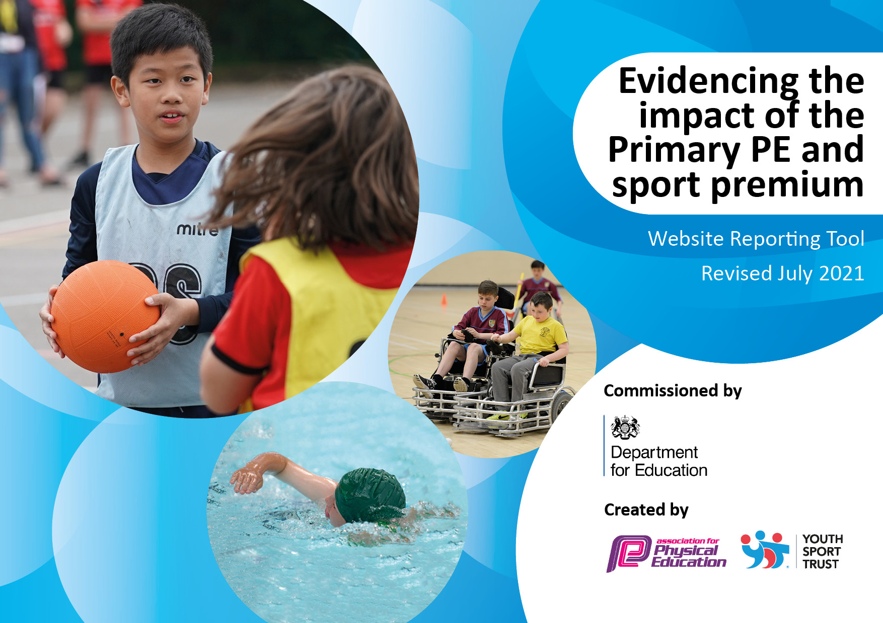

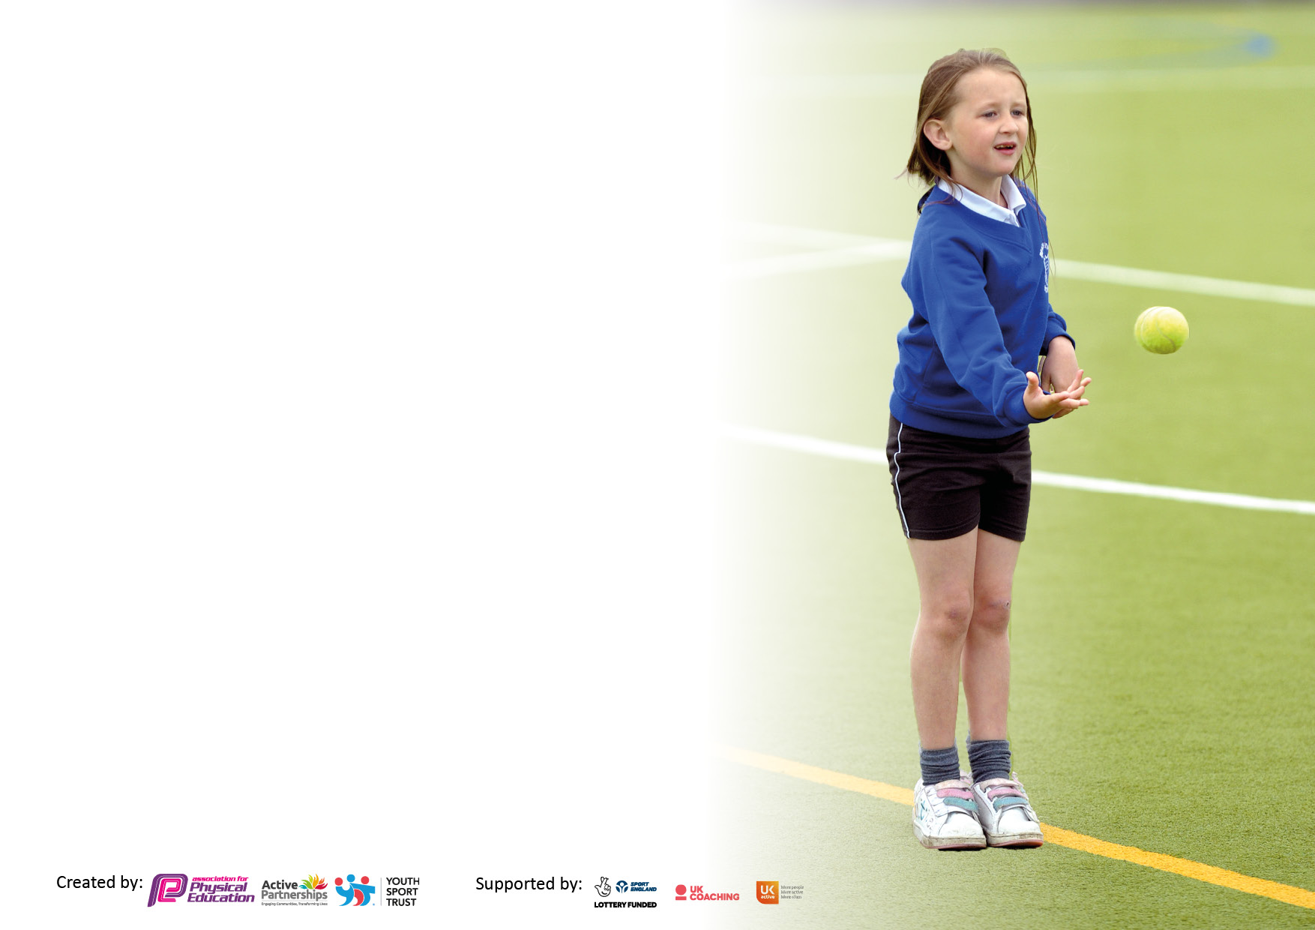

It is important that your grant is used effectively and based on school need. The Education Inspection Framework makes clear there will be a focus on **‘whether leaders and those responsible for governors all understand their respective roles and perform these in a way that enhances the effectiveness of the school’**.

Under the Quality of Education Ofsted inspectors consider:

**Intent** - Curriculum design, coverage and appropriateness

**Implementation** - Curriculum delivery, Teaching (pedagogy) and Assessment

**Impact** - Attainment and progress

To assist schools with common transferable language this template has been developed to utilise the same three headings which should make your plans easily transferable between working documents.

Schools must use the funding to make **additional and sustainable** improvements to the quality of Physical Education, School Sport and Physical Activity (PESSPA) they offer. This means that you should use the Primary PE and sport premium to:

* Develop or add to the PESSPA activities that your school already offer
* Build capacity and capability within the school to ensure that improvements made now will benefit pupils joining the school in future years
* The Primary PE and sport premium should not be used to fund capital spend projects; the school’s budget should fund these.

Pleasevisitgov.ukfortherevisedDfEguidanceincludingthe5keyindicatorsacrosswhichschoolsshoulddemonstrate animprovement.Thisdocumentwillhelpyoutoreviewyourprovisionandtoreportyourspend.DfEencouragesschools to use this template as an effective way of meeting the reporting requirements of the Primary PE and sport premium.

We recommend you start by reflecting on the impact of current provision and reviewing the previous spend.

Schools are required to publish details of how they spend this funding, including any under-spend from 2019/2020, as well as on the impact it has on pupils’ PE and sport participation and attainment. **All funding must be spent by 31st July 2022.**

We recommend regularly updating the table and publishing it on your website throughout the year. This evidences your ongoing self-evaluation of how you are using the funding to secure maximum, sustainable impact. Final copy must be posted on your website by the end of the academic year and no later than the 31st July 2021. To see an example of how to complete the table please click HERE.

Created by: Supported by:

**Details with regard to funding**

Please complete the table below.

|  |  |
| --- | --- |
| Total amount carried over from 2020/21 | £0 |
| Total amount allocated for 2021/2022 | £17,690 |
| How much (if any) do you intend to carry over from this total fund into 2021/22? | £0 |
| Total amount allocated for 2022/2023 | £17,720 |
| Total amount of funding for 2022/2023. To be spent and reported on by 31st July 2023. | £17,720 |

**Swimming Data**

Please report on your Swimming Data below.

|  |  |
| --- | --- |
| Meeting national curriculum requirements for swimming and water safety.  N.B. Complete this section to your best ability. For example you might have practised safe self-rescue techniques on dry land which you can then transfer to the pool when school swimming restarts.  **Due to exceptional circumstances priority should be given to ensuring that pupils can perform safe self-rescue even if they do not fully meet the first two requirements of the NC programme of study** |  |
| What percentage of your current Year 6 cohort swim competently, confidently and proficiently over a distance of at least 25 metres?  **N.B.** Even though your pupils may swim in another year please report on their attainment on leaving primary school at the end of the summer term 2020.  Please see note above | 13% |
| What percentage of your current Year 6 cohort use a range of strokes effectively [for example, front crawl, backstroke and breaststroke]?  Please see note above | 25% |
| **What percentage of your current Year 6 cohort perform safe self-rescue in different water-based situations?** | 13% |
| Schools can choose to use the Primary PE and sport premium to provide additional provision for swimming but this must be for activity **over and above** the national curriculum requirements. Have you used it in this way? | No |

**Action Plan and Budget Tracking**

Capture your intended annual spend against the 5 key indicators. Clarify the success criteria and evidence of impact that you intend to measure to evaluate for pupils today and for the future.

|  |  |  |  |  |
| --- | --- | --- | --- | --- |
| **Academic Year:** 2020/21 | **Total fund allocated:** | **Date Updated:** | |  |
| **Key indicator 1:** The engagement of all pupils in regular physical activity – Chief Medical Officers guidelines recommend that primary school pupils undertake at least 30 minutes of physical activity a day in school | | | | Percentage of total allocation: |
| 57% |
| **Intent** | **Implementation** | | **Impact** |  |
| Your school focus should be clear what you want the pupils to know and be able to do and about  what they need to learn and to  consolidate through practice: | Make sure your actions to achieve are linked to your intentions: | Funding allocated: | Evidence of impact: what do pupils now know and what can they now do? What has changed?: | Sustainability and suggested next steps: |
| Play Leaders to be able to lead games during breaks.*  Sport clubs to be available for all ages and abilities.  Pupils to be able to attend competitions and be able to compete against children their own age.  Run-a-mile to be embedded throughout the school.  A drive on change for life for Years 5 and 6 | * Play leaders will be trained by the sports coach so they are confident at planning, organising and running physical activities for children across the school. PE leader will then monitor the quality and variety of the sessions. * Sports coach will organise a variety of activities for children to take part in at lunchtimes, one lunch time per class. Coaching opportunities with one class each day will also take place. * A variety of after school clubs will be offered to all children free of charge. The sports coach will lead these. PE leader will monitor the uptake of these and target groups of children when necessary. | Lunch Provision  £5,700  After school provision  £ 4,375 | See Appendix 1 for after school club data)  Pupils are able to lead and organise activities for other pupils which ensure there is high engagement in sport and competition during lunch times.  Pupils know that they can attend sports clubs regardless of age or ability. Increased range of after school clubs and increased participation (registers and pupil questionnaires). Over 50% of the school population have attended after school clubs, with all reporting they enjoy the sessions. Weekly competition is in place to allow opportunities to compete against other schools.  Pupils compete against other schools and use their new-found skills to compete effectively against other schools.  School achieved a gold award from the Schools Games Mark and Pathway to Podium. | Track pupils attending competitions to ensure there is a wider range of pupils attending. |
| **Key indicator 2:** The profile of PESSPA being raised across the school as a tool for whole school improvement | | | | Percentage of total allocation: |
| 57% |
| **Intent** | **Implementation** | | **Impact** |  |
| Your school focus should be clear what you want the pupils to know and be able to do and about  what they need to learn and to  consolidate through practice: | Make sure your actions to achieve are linked to your intentions: | Funding allocated: | Evidence of impact: what do pupils now know and what can they now do? What has changed?: | Sustainability and suggested next steps: |
| Raise the profile of PE and sport by engaging and inspiring more pupils across the school to participate and realise the importance of a healthy, active lifestyle.  To be able to compete and enjoy competitions with other pupils their age.  To improve and consolidate skills in order to engage all children of all ages and abilities.  *Subject to change due to Covid-19 | * Sports coach employed to help develop the skills and strengths of the children. * Sporting achievements in and out of school to be shared in Assemblies and on display boards. * A broad range of lunch and after school clubs* to be offered to engage as many children as possible. * PE leader to monitor the engagement of pupils and target disengaged pupils.   Pupil voice interviews to be carried out and activities amended to reflect children’s interests. | Sports coach fees are outline above | (See Appendix 1 for after school club data)  Increased range of after school clubs and increased participation. A wide range of after school clubs has been offered to all year groups.  Increased participation (pupil questionnaires) through discussions with staff to accommodate as many children as possible by offering a wide range of sport. SEND pupils have been targeted for both clubs and competitions with our curling and boccia team wining first place in an inter school competition.  Sports award ceremony evening held. There was high attendance from both parents and pupils.  School achieved the gold award for both the school games award and pathway to podium. |  |

|  |  |  |  |  |
| --- | --- | --- | --- | --- |
| **Key indicator 3:** Increased confidence, knowledge and skills of all staff in teaching PE and sport | | | | Percentage of total allocation: |
| 43% |
| **Intent** | **Implementation** | | **Impact** |  |
| Your school focus should be clear | Make sure your actions to | Funding | Evidence of impact: what do | Sustainability and suggested |
| what you want the pupils to know | achieve are linked to your | allocated: | pupils now know and what | next steps: |
| and be able to do and about | intentions: |  | can they now do? What has |  |
| what they need to learn and to |  |  | changed?: |  |
| consolidate through practice: |  |  |  |  |
| Increased quality in physical education across key stage 1 and 2 to ensure pupils and staff and confident and competent.  The confidence, knowledge and skills of the staff will give the pupils confidence and knowledge that they can build on through their school journey and be able to play and compete successfully with other peers of their age. | * Sports coach to work alongside all class teachers to help build confidence and ability. * Sports coaches to provide lesson plans for the lessons they support. * PE leader to regularly monitor the quality of teaching and learning in all PE lessons. * PE subject leader to meet with a broad range of pupils to talk about their PE lessons and to ascertain their knowledge and understanding of the subject. * Run-a-mile to be embedded in order for the school to be able to monitor children’s fitness and well-being. * Use of the PE Hub to aid and delivering lessons. | Sports coach PE lessons  £7,090  PE Hub Planning Subscription  £441 | Pupils know a range of skills that they did not know before as the lesson plans have planned in a learning journey where skills are built on throughout the pupil’s time at Nonsuch.  Pupils know a range of sporting activities such as: tag-rugby, football, handball, netball, cricket, rounders and athletics as well as gymnastics and dance.  Resources sourced to provide further knowledge to staff to improve skills within the lessons. Including providing staff with access to The PE Hub.  Through informal observations and conversations, the lack of disengaged children in classes has dropped in lessons. Teachers report an increase in participation. SEN pupils are being looked at to ensure lessons are engaging for them.  Teachers receive CPD once a week from Sports Coach to increase confidence, knowledge and skills. | * Developing PE is part of the school improvement plan for 2023/2024 to ensure the school’s lesson structure is followed and to review the curriculum intent. * To develop an assessment tool in PE. |
| **Key indicator 4:** Broader experience of a range of sports and activities offered to all pupils | | | | Percentage of total allocation: |
| 57% |
| **Intent** | **Implementation** | | **Impact** |  |
| Your school focus should be clear | Make sure your actions to | Funding | Evidence of impact: what do | Sustainability and suggested |
| what you want the pupils to know | achieve are linked to your | allocated: | pupils now know and what | next steps: |
| and be able to do and about | intentions: |  | can they now do? What has |  |
| what they need to learn and to |  |  | changed?: |  |
| consolidate through practice: |  |  |  |  |
| Additional achievements:    A broad range of activities will be offered to all children across the school to improve participation and engagement in sport for all pupils, regardless of interest.  To build upon our school life skills in order to represent themselves well when playing against other schools, particularly: independence, challenge, resilience and curiosity.  To use the skills taught in PE lessons and after-school clubs to use in sporting games against other schools.  *Subject to change due to Covid-19  To create a list of local clubs that children can attend to further their love for sport and their skills | * Sports coach employed to plan and lead a variety of clubs, free of charge, across the school. * * PE leader to liaise with SGO to ensure where possible clubs link to competitions.* * Sports coach employed to lead and organise activities at lunchtimes.   Children to be reminded that the life skills in sports should be shown but can also be transferred into the classroom. | See lunch and after school provisions costing above | (See Appendix 1 for after school club data)  Increased range of after school clubs and increased participation (registers and pupil questionnaires)  Pupils know a range of sporting activities such as: tag-rugby, football, handball, netball, cricket, rounders and athletics as well as gymnastics and dance.  Achievements from clubs shared with children in assemblies and social media. | -Sport coach to continue to provide termly plans and activities for after school provision.  -Continue to provide a broad range of after-school activities for all abilities  -Attend as many SGO activities as possible.  -Begin to track gifted and talented in sport and signpost them to local clubs/provision. |

|  |  |  |  |  |
| --- | --- | --- | --- | --- |
| **Key indicator 5:** Increased participation in competitive sport | | | | Percentage of total allocation: |
| 43% |
| **Intent** | **Implementation** | | **Impact** |  |
| Your school focus should be clear | Make sure your actions to | Funding | Evidence of impact: what do | Sustainability and suggested |
| what you want the pupils to know | achieve are linked to your | allocated: | pupils now know and what | next steps: |
| and be able to do and about | intentions: |  | can they now do? What has |  |
| what they need to learn and to |  |  | changed?: |  |
| consolidate through practice: |  |  |  |  |
| Children to increase fine motor skills in games.  Children to enjoy doing sports and to follow up with external clubs  Children to have an increased knowledge of sports | Fine motor skills focus in KS1 through the PE Hub planning.  Classes have experienced Tennis and Cricket at external secondary school.  Children to have more play equipment at lunchtime | Sports coach fees are outlined above  £114 | Increased range of after school clubs and increased participation (registers and pupil questionnaires)  Pupils know a range of sporting activities such as: tag-rugby, football, handball, netball, cricket, rounders and athletics as well as gymnastics and dance.  Achievements from clubs shared with children in assemblies and social media. |  |

|  |  |
| --- | --- |
| Signed off by | |
| Head Teacher: | Sally-Ann Roberts |
| Date: | 07.10.2022 |
| Subject Leader: | M Dunbar |
| Date: | 07.10.2022 |
| Governor: | Margaret Andrew (Chair of Governors) |
| Date: | 15.12.2022 (during full governing body meeting) |