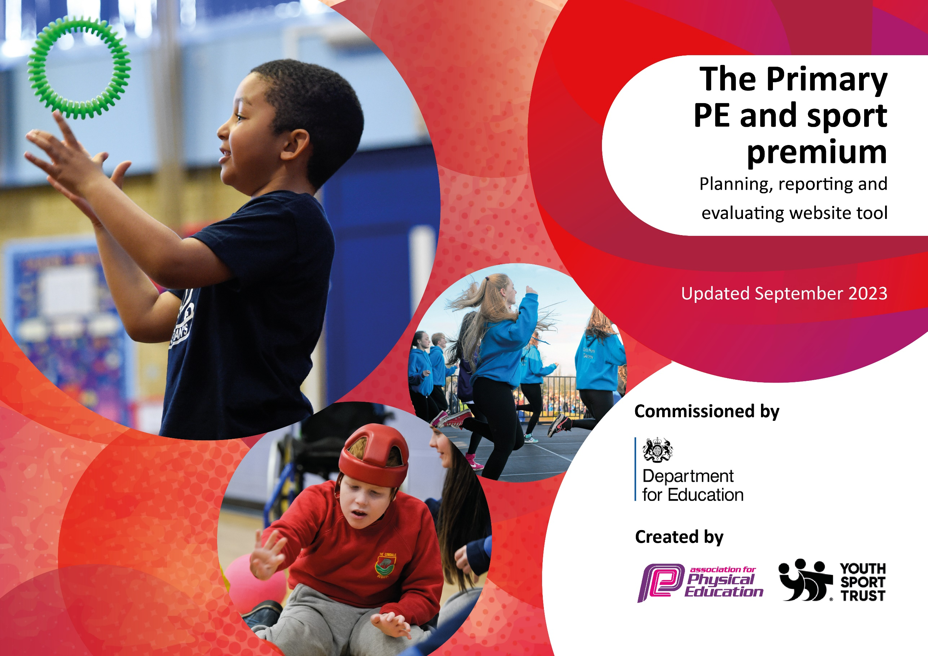

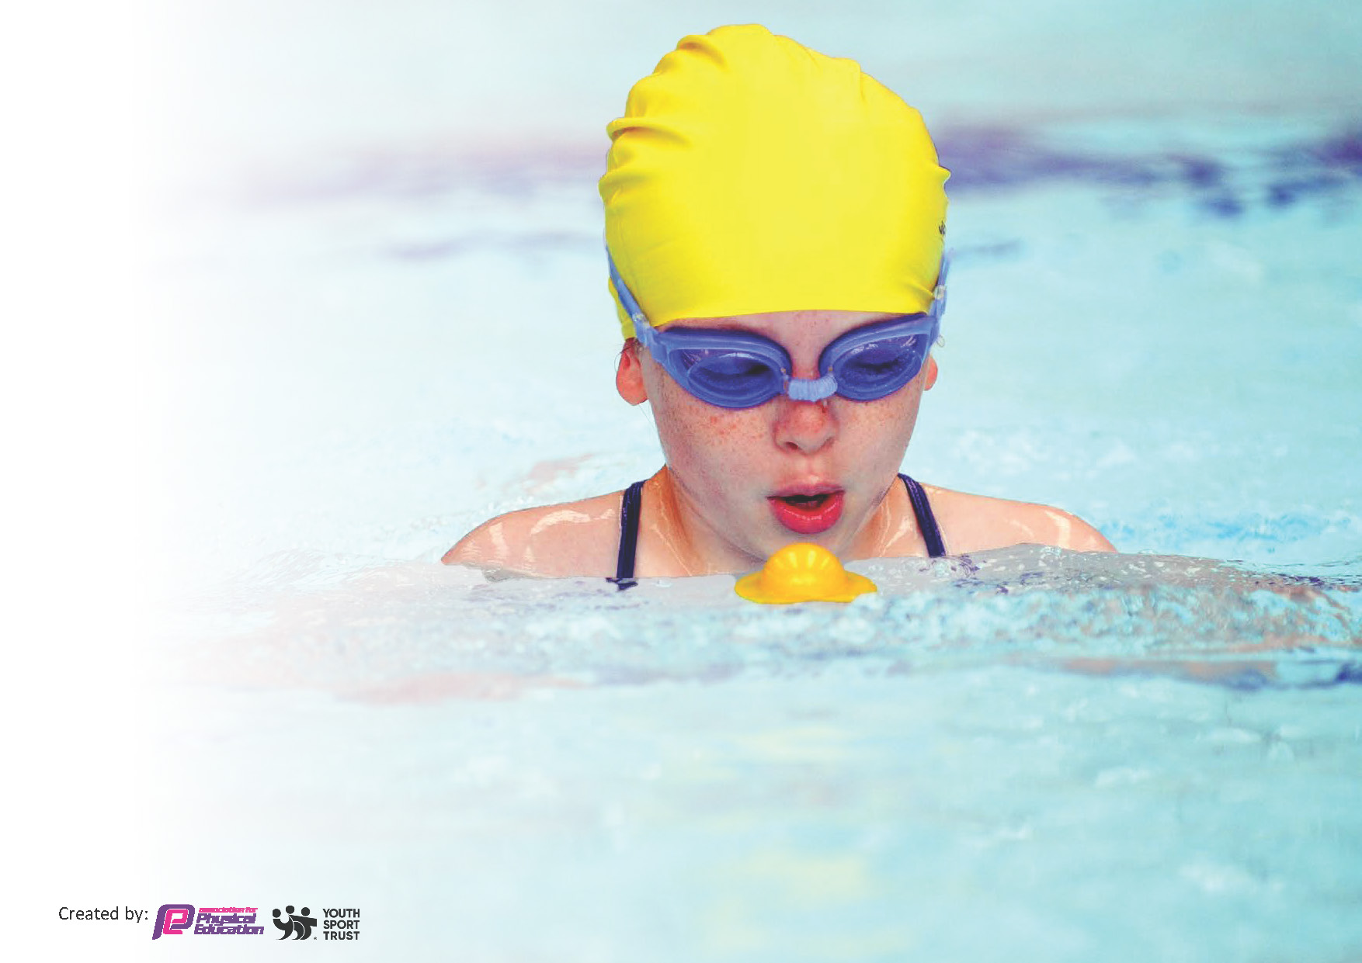
This template can be used for multiple purposes:
by:
- It enables schools to effectively plan their use of the Primary PE and sport premium
- It helps schools to meet the requirements (as set out in guidance) to publish information on their Primary PE and sport premium
- It will be an effective document to support Ofsted inspections enabling schools to evidence progress in Physical Education (PE) and evidence swimming attainment, which forms part of the PE National Curriculum. We would recommend schools consider
the Intent, Implementation and Impact of any spend, as examined within the Education Inspection Framework.

It is important that your grant is used effectively and based on school need.

Schools must use the funding to make additional and sustainable
improvements to the quality of the PE, School Sport and Physical Activity (PESSPA)
they offer. This means that you should use the Primary PE and sport premium to:

- Build capacity and capability within the school to ensure that improvements made now will benefit pupils joining the school in future years
- Develop or add to the PESSPA activities that your school already offers.

The Primary PE and sport premium should not be used to fund capital spend projects; the school’s core budget should fund these. Further detail on capital expenditure can be found in the updated Primary PE and sport premium guidance.

The Primary PE and sport premium guidance, outlines 5 key priorities that funding should be used towards. It is not

necessary that spending has to meet all the key priorities, you should select the priorities that you aim to use any funding towards.

Although completing this template is not a requirement for schools, schools are required to publish details of how they spend this funding. Schools must also outline what the impact this funding has had on pupils’ PE and sport participation and attainment and how any spending will be sustainable in the future. All funding must be spent by 31st July 2024.

The Department for Education has worked closely with the Association for Physical Education (afPE) and the Youth Sport Trust (YST) to develop this template and encourages schools to use it. This template is an effective way of meeting the reporting requirements of the Primary PE and sport premium.
Review of last year’s spend and key achievements (2022/2023)

We recommend you start by reflecting on the impact of current provision and reviewing your previous spend.

Activity/Action | Impact | Comments
Play Leaders to be able to lead games during breaks.  Sport clubs to be available for all ages and abilities.  Pupils to be able to attend competitions and be able to compete against children their own age.  Raise the profile of PE and sport by engaging and inspiring more pupils across the school to participate and realise the importance of a healthy, active lifestyle.  To improve and consolidate skills in order to engage all children of all ages and abilities.  Increased quality in physical education across key stage 1 and 2 to ensure pupils and staff and confident and competent.  To build upon our school life skills in order to represent themselves well when playing against other schools, particularly: independence, challenge, resilience and curiosity.  Children to increase fine motor skills in games. | Children were involved in facilitating games more during break and lunch times.  Children had access to a range of clubs  Children attended competitions both in school and off-site with other schools  Birmingham Healthy schools provided CPD for teachers and therefore children were educated on the importance of healthy eating  Children were able to build upon their skills from previous years due to the PE hub programme of study  Staff were more confident in delivering PE lessons when it was their own session to deliver.  Children were able to represent the school well, including the resilience of the games.  An increase in fine motor was shown at a more rapid pace for EYFS children compared to last academic year.

Key priorities and Planning
This planning template will allow schools to accurately plan their spending.

Action – what are you planning to do | Who does this action impact? | Key indicator to meet | Impacts and how sustainability will be achieved? | Cost linked to the action
Sports coach to work alongside all class teachers to help build confidence and ability to teach sports effectively  Sports coaches provide lesson plans for the lessons they support.  PE leader to regularly monitor the quality of teaching and learning in all PE lessons.  PE subject leader to meet with a broad range of pupils to talk about their PE lessons and to ascertain their knowledge and understanding of the subject.  Run-a-mile to be embedded in order for the school to be able to monitor children’s fitness and well-being.  Use of the PE Hub to aid and delivering lessons. | Class teachers, teaching assistants, pupils  Class teachers, teaching assistants, pupils, SEN pupils for adaptions  Class teachers, PE lead, SLT to enhance provision from findings, all children  Class teachers, PE lead, SLT to enhance provision from findings, all children  Children to benefit from this with increased fitness  Class teachers, PE lead, SLT to enhance provision from findings, all children | Key Indicator 1: Increased confidence, knowledge and skills of all staff in teaching PE and sport  Key Indicator 1: Increased confidence, knowledge and skills of all staff in teaching PE and sport  Key Indicator 1: Increased confidence, knowledge and skills of all staff in teaching PE and sport  Key Indicator 1: Increased confidence, knowledge and skills of all staff in teaching PE and sport  Key Indicator 1: Increased confidence, knowledge and skills of all staff in teaching PE and sport  Key Indicator 1: Increased confidence, knowledge and skills of all staff in teaching PE and sport | Teachers’ pedagogical knowledge will increase  Teachers’ pedagogical knowledge and delivery will improve  Teachers’ pedagogical knowledge will increase via feedback  Teacher’s pedagogical knowledge will be assessed so future training can be implemented to further support  Children will engage in physical activity throughout the day, with more pupils reaching their daily physical goal  Children will receive high-quality lessons | Cost of a sports coach: £16,988  Cost of a sports coach: £16,988  Cost of Pe Hub Subscription: £320  In house cost  In house cost  PE Hub Subscription: £320
A broad range of activities will be offered to all children across the school within lunchtime to improve participation and engagement in sport for all pupils, regardless of interest.  Enhance the continuous provision for EYFS, Yr 1 and children with SEN with more gross motor activities | All pupils within the school  All pupils within EYFS, Yr 1 and SEN children | Key Indicator 2: Engagement of all pupils in regular physical activity | Children to enjoy doing sports and to follow up with external clubs  Children to enjoy the activities and follow up with this at home | Sports coach for lunch provision: £392  In house cost.
Birmingham Healthy Schools to be contacted to provide CPD for teachers so that they can raise the importance of a healthy, active lifestyle to children and sent out to parents  Children to study women who have been successful in sporting events throughout the curriculum | Class teachers, PE lead, SLT to enhance provision from findings, all children  Class teachers, PE lead, SLT to enhance provision from findings, all children | Key Indicator 3: The profile of PE and sport is raised across the school as a tool for whole school improvement | Children to follow up these healthy eating habits at home  Children to follow up these sports externally as they have been exposed to them | £0. Birmingham healthy schools came in to support with no fee and provided the parental leaflets
Children to have experienced a range of sports for a broader experience such as Tri Hockey, Netball, Kingball, Cricket, Tennis, Rounders and Target games  Children to be presented with specialist teaching in areas of sport children would not normally be exposed to. Cricket to be delivered from the secondary school | All pupils in school  KS2 pupils in school | Key Indicator 4: Broader experience of a range of sports and activities offered to all pupils |  | £108.60 – additional hours for the sports coach  £0. Liaised with the secondary school and they will come in for free.
Children to have experienced a range of sports for a broader experience such as Tri Hockey, Netball, Kingball, Cricket, Tennis, Rounders and Target games  Sports Day set up and delivered by Sports Coach  Children to have received awards for sporting participation | All pupils in school  All pupils in school and teachers  All pupils in school | Key Indicator 5: Increased participation in competitive sport | Children to take up these sports externally  Children to enjoy competitive sports and take up these activities externally  Children to become more motivated to join after school clubs and external clubs | £108.60 – additional hours for the sports coach  £108.60 – additional hours for the sports coach  £40 – additional cost for trophies and medals

Key achievements 2023-2024
This template will be completed at the end of the academic year and will showcase the key achievements schools have made with their Primary PE and sport premium spending.

Activity/Action | Impact | Comments
Children to have experienced a range of sports for a broader experience such as Tri Hockey, Netball, Kingball, Cricket, Tennis, Rounders and Target games  Sports coach to work alongside all class teachers to help build confidence and ability to teach sports effectively  PE Hub subscription of lesson plans that have been delivered by the sports coach to increase teachers’ pedagogical knowledge  Children to have received awards for sporting participation  Birmingham Healthy Schools to be contacted to provide CPD for teachers so that they can raise the importance of a healthy, active lifestyle to children and sent out to parents  Enhance the continuous provision for EYFS, Yr 1 and children with SEN with more gross motor activities  A broad range of activities will be offered to all children across the school within lunchtime to improve participation and engagement in sport for all pupils, regardless of interest. | Children received sports events that they would not normally be exposed to, ensuring they have a broad range of sporting experiences  This increased the confidence of teachers in their pedagogical knowledge, particularly ECTs through a coaching programme run by the sports coach  This has increased the confidence of teachers leading PE. This has also enhanced their subject specific knowledge, particularly ECTs  Children were successful and won medals and trophies at sporting competitions that were ran externally against other children their age.  Children were educated regarding healthy eating through the Birmingham Healthy Schools programme and leaflets and communication was sent home to support families.  A space in KS1 was allocated for gross motor activities and the EYFS, Year 1 and SEN children benefited from an increase in gross motor activities.  Children were offered a broad range of sporting events on a lunch time and therefore this improved their participation in sports. | Children received medals for taking part in these experiences

Swimming Data
Meeting National Curriculum requirements for swimming and water safety.
Priority should always be given to ensuring that pupils can perform safe self-rescue even if they do not fully meet the first two requirements of the National Curriculum programme of study

Question | Stats: | Further context  Relative to local challenges
What percentage of your current Year 6 cohort can swim competently, confidently and proficiently over a distance of at least 25 metres? | 20% (6/30) | Children receive swimming lessons in Yr 4,5 and 6. However, within this cohort, 7 children left us and 9 children arrived at the end of Year 5. Those 9 children were not confident swimmers.
What percentage of your current Year 6 cohort can use a range of strokes effectively [for example, front crawl, backstroke, and breaststroke]? | 20% (6/30) | See above

What percentage of your current Year 6 cohort are able to perform safe self-rescue in different water-based situations? | 20% | See above
If your schools swimming data is below national expectation, you can choose to use the Primary PE and sport premium to provide additional top-up sessions for those pupils that did not meet National Curriculum  requirements after the completion of core lessons. Have you done this? | Yes/No | Pupil premium money is being used to add in additional swimming lessons as the sports coach is allocated to this budget
Have you provided CPD to improve the knowledge and confidence of staff to be able to teach swimming and water safety? | Yes/No | This is supported by the swimming instructor within the swimming baths. The swimming instructor additionally takes the swimmers who are underperforming in order to ensure they get specialist swimming direction.

Signed off by:

Head Teacher: | Siobhan Sanders
Subject Leader or the individual responsible for the Primary PE and sport premium: | Zara Lay
Governor: | Margeret Andrew (Chair of Governors)
Date: | December 2023 (During full governing body meeting)

